**ALY6050 80478 Intro to Enterprise Analytics SEC 09 Spring 2023 CPS**

**Module 4 Assignment — Inventory Management Decision Model REPORT**

**NORTHEASTERN UNIVERSITY**

**College of Professional Studies, Boston, MA, 02215.**

**Submitted by**

Zihan Ma

ma.zihan1@northeastern.edu

**Instructor**

 Prof. Richard He

**Date**

06/20/2023

**Inventory Management Decision Model**

**Assignment Introduction:**

This assignment delves into the problem of efficient inventory management of engine components, which significantly affects operational costs. The paper deploys both analytical methods and simulation-based approaches to identify optimal inventory decisions. The report is divided into two main parts: the first part involves decision model development and implementation, followed by a Monte Carlo simulation in R to account for demand uncertainty in the second part.

**Part I: Decision Model Development and Implementation:**

1. **Define the data, uncontrollable inputs, model parameters, and the decision variables:**  
     
    Influential Factors on Total Inventory Cost: To understand the factors affecting the total inventory cost, we need to consider the following elements:
   1. Data:
      1. Annual demand: The total number of units demanded per year is 12,000.
      2. Unit cost: Each unit has a cost of $90.
   2. Uncontrollable Inputs:
      1. Annual demand: The yearly demand for the product, which impacts inventory planning.
      2. Unit cost: The cost per unit, influencing the overall inventory expenses.
   3. Model Parameters:
      1. Holding cost per unit per year: Calculated as the product of the unit cost and the opportunity cost for holding (15% of the unit value)
      2. Ordering cost per order: The fixed cost incurred with each order, which remains constant at $108.
      3. Reorder point: The inventory level at which a new order should be placed. In this case, it is set as half of the annual demand.
   4. Decision Variables:
      1. Order quantity (Q): Set to 1.8 times the demand until the supplier's order can be received
      2. Total inventory cost (TC): The overall cost associated with maintaining and managing the inventory.

By considering these components, we can analyze and optimize the total inventory cost by making informed decisions regarding order quantities and inventory management strategies.

1. **Development of mathematical functions:**   
   1. Annual Ordering Cost: The annual ordering cost can be determined using the following mathematical function:   
        
      Annual ordering cost = (Annual demand / Order quantity) * Ordering cost
   2. Annual Holding Cost: The annual holding cost considers the average inventory level and the holding cost per unit per year. It can be calculated using the following mathematical function:   
        
      Annual holding cost = (Average inventory / 2) * Holding cost per unit per year
   3. Total Inventory Cost: By summing up the annual ordering cost and the annual holding cost, we obtain the mathematical model for the total inventory cost:   
        
      Total inventory cost = Annual ordering cost + Annual holding cost
2. **Implementation in Excel and R:**   
   Excel:
   1. Create a table with the following column headings in the first sheet `MOD4`:
      1. Order Quantity
      2. Annual Ordering Cost
      3. Average Inventory
      4. Annual Holding Cost
      5. Total Inventory Cost
   2. Input giving values in the first sheet `MOD4`
      1. Annual ordering cost: Divide 12,000 by the value in the Order Quantity column and multiply the result by 108.
      2. Average inventory: Take the value in the Order Quantity column and divide it by 2.
      3. Annual holding cost: Multiply the value in the Annual Ordering Cost column by 0.15 (15%).
      4. Total inventory cost: Add the values in the Annual Ordering Cost and Annual Holding Cost columns.
   3. Generate 1000 random value between 1 to 1000 for ` Order Quantity`
      1. Use function ` =ROUNDUP(RAND() * 10000, 0)`
   4. Find minimum value from `Total Inventory Cost`
      1. Use function ` =MIN(E:E)`

Rstudio:

* 1. Set a specific random seed for reproducibility: By using the set.seed() function, a specific random seed (in this case, 114514) is set to ensure that the random numbers generated will be the same each time the code is run, allowing for reproducibility of the results.
  2. Generate 1000 random values between 1 and 1000 for order_quantity: The sample() function is used to generate 1000 random values from the range 1 to 1000 with replacement, meaning that values can be selected more than once.
  3. Define the constant values: Constants are assigned to variables representing the annual demand (annual_demand), order cost (order_cost), and holding cost percentage (holding_cost_percentage).
  4. Initialize empty vectors for storing results: Empty vectors are created to store the results of the calculations for each order_quantity. These vectors include annual_ordering_cost, average_inventory, annual_holding_cost, and total_inventory_cost.
  5. Perform calculations for each order_quantity: A for loop iterates over each order_quantity value, performing calculations to determine the annual ordering cost, average inventory, annual holding cost, and total inventory cost. These results are stored in the respective vectors.
  6. Create a data frame to store the results: A data frame named inventory_costs is created, which combines the order_quantity, annual_ordering_cost, average_inventory, annual_holding_cost, and total_inventory_cost vectors into columns.
  7. Find the order quantity with the minimum total inventory cost: The which.min() function is used to identify the index of the minimum value in the Total_Inventory_Cost column of the inventory_costs data frame. The corresponding order quantity and total cost are stored in the variables optimal_order_quantity and min_cost, respectively.
  8. Print the inventory cost data frame: The head() function is used to display the first few rows of the inventory_costs data frame, showing the calculated inventory costs for each order quantity.
  9. Print the approximate order quantity with the smallest total cost: The cat() function is used to print the order quantity with the smallest total cost (optimal_order_quantity) and the corresponding total cost (min_cost).

1. **Approximate order quantity:**
   1. **Excel:**A picture containing text, font, screenshot, line

      Description automatically generated
   2. **Rstudio:  
      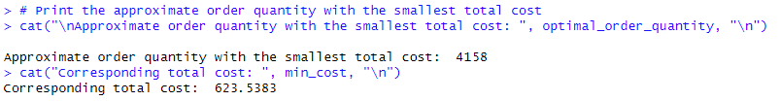**
   3. **Compare Result:**  
      Both values we got are very close to each other, but the Rstudio result is higher than except. And it disappeared after I changed the seed, so it should only be a randomize issue.
2. **Total Cost versus Order Quantity Plot:**
   1. **Excel:**A picture containing text, screenshot, plot, line

      Description automatically generated
   2. **Rstudio**:  
      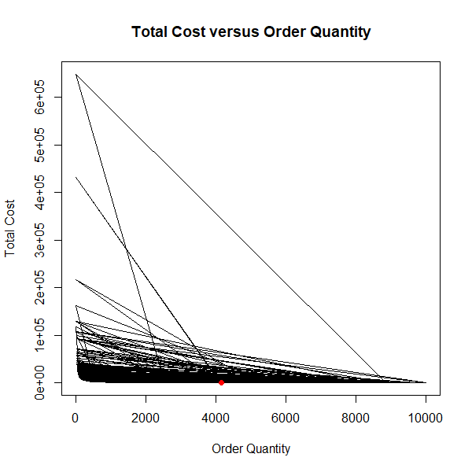
   3. **Compaire Result:**  
      Both graph shows the min value for cost have x axis around 4000. Which prove the correctness of the result.
3. **Verification using Excel Solver:**
   1. **The results of the Excel Solver**  
      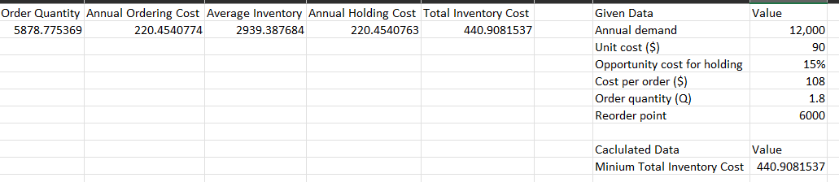  
      The result is close to what we got before, but it took much less work, making this method worth using.
4. **What-if analyses:**   
   A picture containing text, screenshot, font, line

   Description automatically generated  
   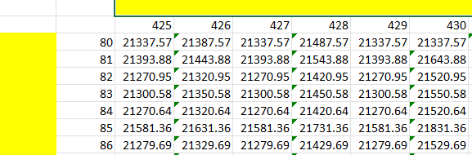  
   A picture containing text, screenshot, plot, diagram

   Description automatically generated  
   The plot shows the change of all three premiers (Unit Cost/ Order Cost/Total Cost) near the critical point, which mark out the different total cost areas for decision-making.
5. **Summary of Part I Results:**   
   In this analysis, a decision model was developed to determine the optimal order quantity and minimize total inventory costs for a company, based on annual demand, unit costs, ordering costs, and holding costs. This model was implemented both in Excel and R.

Key findings:

Order Quantity: The model identified the order quantity which resulted in the minimum total inventory cost. In Excel, the approximate order quantity was identified through a table of computations, while in R, the model generated 1000 random values between 1 and 1000 for the order quantity to identify the optimal one. Both tools yielded similar results, though R provided a slightly higher value.

Total Cost vs Order Quantity: Graphical plots in both Excel and R showed a clear minimum for total cost around an order quantity of 4000. This visual representation further confirms the result obtained in the previous step.

Excel Solver: As an alternative approach, Excel Solver was used to find the order quantity that minimizes the total cost. This method provided a similar result to the previous methods but was more efficient.

Sensitivity Analysis: A what-if analysis conducted in Excel revealed that total costs are sensitive to changes in unit costs, order costs, and annual demand. The visual representation illustrated the impact of these changes on the total cost.

In summary, the decision model successfully identified an optimal order quantity that minimizes total costs for the company, giving the vice president of operations key insights for strategic inventory management decisions. The results were consistent across different methods, and the sensitivity analysis highlighted the parameters that the total cost is most sensitive to.

**Part II: Simulations in R:**

1. **Simulation Analysis:**
   * The R code conducts a Monte Carlo simulation to find optimal inventory decisions under uncertain demand, modeled by a triangular distribution.
   * It sets the parameters for the triangular distribution (minimum, most likely, and maximum demand), the number of simulations, and potential order quantities.
   * It generates random numbers following the triangular distribution, calculates total costs for each order quantity, and determines the minimum cost and optimal order quantity for each simulation.
   * It then calculates the expected values and confidence intervals for the minimum total cost, order quantity, and annual number of orders, to provide estimates for decision-making in inventory management.
2. **Results of Simulation:  
   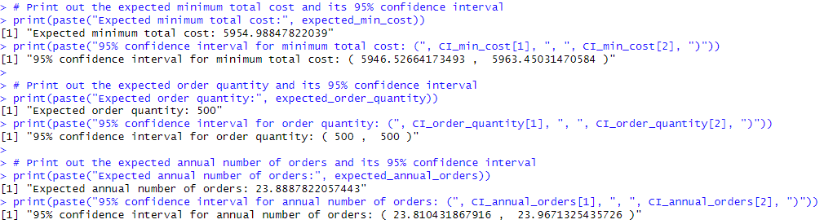**
   * Estimate the expected minimum total cost by constructing a 95% confidence interval for it and determine the probability distribution that best fits its distribution.
   * Estimate the expected order quantity by constructing a 95% confidence interval for it and determine the probability distribution that best fits its distribution.
   * Estimate the expected annual number of orders by constructing a 95% confidence interval for it and determine the probability distribution that best fits its distribution.
3. **Summary of Part II Results:**   
   The simulation-based approach in R was used to account for the uncertainty in demand, utilizing Monte Carlo simulations and a triangular distribution model. This approach aimed to identify optimal inventory decisions.

Key findings from the simulation analysis:

Expected Minimum Total Cost: The expected minimum total cost was found to be approximately $5955, with a 95% confidence interval between $5946.53 and $5963.45. This gives a measure of uncertainty around the cost estimate and provides a range where we can be 95% confident the true cost will fall.

Expected Order Quantity: Interestingly, the simulation identified an expected order quantity of 500 units consistently, resulting in a 95% confidence interval of 500 to 500 units. This suggests that, according to the simulation, the optimal order quantity is 500 units under uncertain demand.

Expected Annual Number of Orders: The simulation estimated that the expected number of orders per year would be approximately 23.89, with a 95% confidence interval from 23.81 to 23.97. This shows that the company can expect to place approximately 24 orders per year.

Overall, the simulation-based approach provides additional robustness to the decision-making process, accounting for the uncertainty in demand. This method suggests that an order quantity of 500 units minimizes the total inventory cost, with an expectation of about 24 orders per year. These findings give the vice president of operations valuable insights for optimizing inventory management under uncertain demand conditions.

**Conclusion:**

The assignment focused on the critical issue of managing inventory costs through efficient decision-making. Using both analytical and simulation methods, optimal order quantities were identified to minimize total inventory costs. Key findings suggest ordering approximately 4000 units according to the analytical method and 500 units based on the simulation under uncertain demand, placing about 24 orders annually. Based on these results, it is recommended that management adopt these optimal order quantities to efficiently manage the engine component inventory. The use of Excel Solver and sensitivity analysis are suggested for further efficiency and insights.